**Human Aspects of Computer Science (HACS)  
Module component  
Open Group Assessment: Design Project**

**1.1 - Group Assessment Report**

**GROUP E6**

Matthew Gilmore

Oliver Driver

Yuqing Gong

Heng Xu

Shixin Ji

Jamie Todd

Maya Jovanovic

**1.1.1 User Requirements Gathering** **3**

**1.1.2 Scenario Based Design** **5**

**1.1.3: Interactive System Prototype and Evaluation** **7**

**Appendices** **16**

**References** **23**

## 

## **1.1.1 User Requirements Gathering**

We will be producing a prototype for a flights and holiday booking system, however to do so effectively and efficiently with certainty of the system being better than those already released, we will need data to work upon. We aim that our system would be used by families and students due to there being a high proportion of these groups which like going travelling. The next biggest would be those travelling through business however these probably wouldn’t book through a holiday booking system, but rather more professional systems targeted to these people. Business travellers would also most likely have different preferences on how they book flights.

To gather data on appropriate user requirements for our target user groups, we conducted 21 audio recorded interviews. A mix of students and parents were interviewed, as we are designing this system for these two user groups, hoping to create a model meeting the needs of such people.

We asked each user if they would like to be interviewed, and if so if they wished to be voice interviewed. If not, we wrote down what they were answering into text documents. Each member of the group aimed for 3 interviews to produce a large collection of interviews of families and students to make sure our data would be reliable. Analysing this data, common user requirements become noticable.

One such requirement is that the interviewees used a variety of different devices to book holidays such as desktop and laptops. Additionally, in the case where Wi-Fi isn’t available, such as on a train or the user prefers to use a mobile device, an app would expand the user-base of the system. Also users stated they would select different seat types with almost all students stating they would select economy as it was cheaper, so we could display when there are sales on different tickets to persuade these users to purchase them. Some interviewees found it helpful to be able to book transport on the websites and would want to book flights on trusted websites which do not have any advertisements.

There were a large number of varying answers to the questions we produced which simply would be too difficult to implement solutions to every need, however we can aim to target as many as possible which the general users would need and use. To help us with this task of abstraction, we created a persona for each user group to guide us through the development process and what user requirements we must tick off.

**Persona 1 (Student)**

***Demographics:***

Name: Tracey Owens

Age: 20

Marital Status: In a relationship

Job: Waitress (Part time)

***Goals:***

* Travel with her boyfriend Jeremy to Asian Countries
* Hire a moped for the duration of the trip
* Looks for student discounts at places to stay and visit

***Bio:***

Tracey is a 3rd year student currently studying a BA in Art & History at the University of York. She travels to London regularly to see her family and college friends. She balances her working hours at a steakhouse with her studying leaving little time left for shopping and swimming at a local gym.

She hopes that a long 1 month summer vacation with her boyfriend travelling between various East Asian countries would help her relax from a busy schedule. She wants to look at the differing styles of building and to visit shopping malls in varying capitals. Staying at cheap hotels and hostels is important as she can save her budget for shopping and travelling between the cities. At the different hostels she wants to make some new friends who can show them around the cities.

She has a budget of £3000 for non-flight purchases however she wishes to get a bargain on booking flights with her boyfriend early.

***Technology Use:***

* An Apple iPhone 4s which she uses to contact her friends, family and boyfriend using messenger and snapchat. The operating system is outdated so she struggles to install new apps.
* A Microsoft Surface Pro 3 with pen which she uses for drawings in her course and writing notes of travelling plans.

**Persona 2 (Parents)**

***Demographics:***

Names: Sharon and James Walsh

Age: 35 and 40

Marital Status: Married, one daughter and one son.

Jobs: Teacher and Secretary

***Goals:***

* Have a relaxing holiday away from jobs
* Spend time with children
* Enjoy themselves without excessive spendings

***Bio:***

Sharon and James work busy lives and rarely get to spend an extended time with their children, aged 10 and 8. Both Sharon and James have managed to book the same week off to take a relaxing break and have some family time. Both are average with technology due to their jobs and have good experience in money saving. As a result of the work Sharon and James have to do daily, they want their experience when booking a holiday to be quick, simple and cheap.

Both Sharon and James would find it easier if there could be interaction with a person to organise the holiday for them as they have busy timetables. They like flights to closer destinations such as around Europe as long flights and connected flights leave the children bored.

***Technology Use:***

* Have a desktop computer
* Mainly use phones to look for flights and holidays and regularly message each other with upcoming deals

For our personas, we believe they would be able to complete a couple of different tasks suited to them. We believe all user groups should be able to use the main functionality of the website easily without much effort, to be able to book a flight, a hotel alongside this with transport to and from the airports.

For specific user functionalities, we believe implementing a messaging feature such that the students may be able to notify their friends on which flights and accommodation they are booking, without needing them to go out of the app to other messaging apps as this wouldn’t be as efficient. Also, we want to implement features of transport of various sizes too and from airports to hotels to accommodate for larger groups of people such as families who would have more people and have a lot more luggage.

## **1.1.2 Scenario Based Design**

**Scenario 1 (as-is)**

The following scenario describes the interaction between Tracey Owens, persona 1, described above, and holiday website she intended to make arrangements for her trip to Asia on.

Scenario

After a stressful final year of university, Tracey wants to take a long vacation for a month travelling around Asia. She goes onto the website of a holiday company she remembers her parents using for family holidays as a child, assuming reliability. However, she runs into an issue with this service meeting her needs. The website has a focus on package holidays and saving money via return tickets. She needs a series of flights from various countries to various countries on her trip around Asia, not a one trip return holiday, although there are lots of options and destinations, all bookable very in advance. She likes how the flights and the hotels are on the same website for the convenience of it. All the rental transport options immediately shown are cars. She goes to the filtering options but there is no way to search for rentable mopeds.

Claims Analysis

* Flights were roped into inflexible package deals
* Money saving deals available
* Many aspects of planning a trip on one website is convenient
* Can’t specifically search for the vehicle type she wants to rent
* The focus on in-advance booking suits Tracey’s organisational preferences

**Scenario 2 (to be)**

Tracey Owens, persona 1, now interacts with E6Flights in her quest to plan a trip around Asia.

Scenario

Tracey uses the obvious searching feature to find a flight to her first location from the UK. She’s delighted to see the flights are one way, and that she can search for flights from non-UK airports to non-UK airports. She can search for specific dates, allowing her to plan in advance.

When using the travel arrangements page, she can specify at which airport she can get a car from and on which date. She can make further refining searches, giving the number of seats she would like and then filter cars from low to high price.

Flights, accommodation and travel arrangements can be booked separately if necessary.

Claims Analysis

* Can filter cheaper cars with a specified number of seats
* Can be used on mobile for access during the busy day
* On the homepage, locations can be clicked on the interactive map when using a desktop, allowing the discovery of new places when exploring.

**Scenario 3 (as-is)**

The following scenario describes the interaction between Sharon and James Walsh, persona 2, and the holiday website they intended to use in order to book their holiday and travel arrangements alongside it.

Scenario

Sharon and James are both busy workers and find it difficult to find an extended amount of time in order to research for a holiday. They complete a google search and find a flights website that claims to be ‘helpful and swift’ in their booking procedures. Immediately when the website is loaded, Sharon and james both notice that there is no easy way to navigate through the website as it follows a long format that can only be used when booking a holiday. The website requires Sharon and James to log in. They create and account and find that the website provides multiple pop up ads in which they have to close. Once they have found a flight they agree is acceptable, transport is forced to be added. The process follows one long serial format and doesn’t allow them to look for primarily cars or flights.

Claims Analysis

* Website did not allow fast navigation
* Website didn’t allow just flights or just transport to be selected
* Forced login
* Main focus of the website was not delivering their service

**Scenario 4 (to be)**

The following scenario describes the interaction between Sharon and James Walsh, persona 2, and E6flights, as they use the website to find the cheapest flights and transport to a certain destination

Scenario

Sharon and James load up the website and are faced with a easy to read homepage that immediately allows them to add their preferences on destinations and dates. A simply formatted list of flights is shown, which can be ordered to their preferences and provides information on the flights that isn’t overwhelming. The top bar allows them to navigate to search for hotels and transport in which they may like to base their flights off. Login/ register is optional and not excessive. This allows preferences to be saved for next time, where the speed of searching related flights will be quicker.

Claims Analysis

* Fast search for flights
* Easily navigable around due to top bar
* Lets user save preferences with unforced login
* Users can view travel and accommodation arrangements without looking at flights

## 1.1.3: Interactive System Prototype and Evaluation

For our interactive systems to be successful, they not only must follow the personas of our interviewees for targeted production of the systems, but also must adhere to good planning to ensure the systems allow fast, sensical navigation to help users complete their desired tasks.

Bruce Tognazzini “Tog” produced a list of design principles in relation to websites (although many are applicable to apps) to allow developers to produce systems which work well with human interaction. He states that “[*Effective applications and services perform a maximum of work, while requiring a minimum of information from users*](https://asktog.com/atc/principles-of-interaction-design/)” [1]. The systems we produce should follow this essential concept stating that users should put in as little effort to complete their task as feasibly possible.

Some examples of principles stated by Tog [1] that are easy to follow an implement into our systems are:

**Aesthetics:**

A system shouldn’t be plain as users wouldn’t feel satisfied using the

System, however this shouldn’t hinder usability of the system in a way to slow navigation about the website or make it complex to use.

**Consistency:**

This will allow navigation around the systems be similar across platforms, with aesthetics having minimal differences. Additionally, users should be able to landmark sections of the website to be able to navigate around the website quickly when on any page. All colour selections should be consistent across the systems.

**Efficiency of the user:**

All actions that the user must carry out should be non-excessive for what the systems should be able to automatically accomplish. Also, buttons should be placed in meaningful locations with short travel times between options the user may select to reduce time to complete tasks.

**Fitts’ Law:**

Essentially, a system’s important, interactive features a user may select should be large enough to be quickly selected. This however shouldn’t be excessive as to distract users from completing their task or as to intrude into the aesthetics of the system.

**Readability:**

A system should be quickly understood by its user. For example, font should be large enough to be readable, even from a short distance but also fit the aesthetics of the systems. The text not only must be large enough, but be well contrasted with its background such that any user, even with impaired vision, may distinguish what the text says. This links to well-thought colour selection as to pick colours which any user may contrast with each other to account for users with colour blindness, ensuring they are non-disadvantaged when using the systems.

**Simplicity:**

Users shouldn’t be overwhelmed by the aesthetic of a system as this slows

navigation about the system and convolutes the system unnecessarily.

**Visible Navigation:**

There shouldn’t be any broken links within the systems and users should be able to navigate between pages easily and naturally.

At each stage in developing the systems these principles should be consulted to guarantee good design and be produced with users in mind at all times.

The system was designed with the main functionality being ease of access and navigation. Our personas both felt that it was highly beneficial to be able to navigate and access different information on flights, hotels and transport with as much ease as possible. Accounts can be created in order to save preferences and favourites for another time. Additionally, this allows the system to recommend similar flights, cars and hotels.

For our low fidelity prototypes/ mockups of the systems (website and mobile app) we have developed multiple screens which will provide the layout of all the functionality the systems need, without the necessary coding and implementation which would be thought as a postcondition if the systems were to be developed.

The list of different screens can be labelled as:

* Home Page
  + This will introduce users to the website allowing options to navigate to other pages of the website using the toolbar with a clear, simplistic design which is inviting to the user. Users will be able to navigate to the screens where they can book their flights and a button where they can access the login page so they can access their account.
* Login Page
  + This will allow the user to create/ access their account page for the duration of the session.
* Account page
  + The user’s account page will contain a view of their profile, the flights that they have looked at previously, their bookmarked flights, travel arrangements, an option to go to their message screen, etc..
* Message page
  + On this screen, the users will be able to add their friends and invite them to private/ group chats where they can discuss and share flight/ travel arrangement details before booking. This would be ideal for the student personas allowing them to plan ahead with their friends for travelling more easily.
* Listings Screen
  + This screen will allow the user to filter through a large database of flight details via the price, date, seat types, departure and arrival locations, connection time and other parameters. This will help the user decide on flights to choose and help them book these specific flights by selecting them.
* Travel Arrangements Page
  + This screen allows users to search for the available cars at an airport between 2 dates. Advanced searches can be made to specify the number of seats the cars have and the transmission type. Cars will then be displayed as a list below, which can be ordered to the users preference
* Hotels screen
  + This screen allows users to search for available accommodation at a location between 2 dates. The user can specify the number of beds needed. Rooms will then be displayed as a list below, which can be ordered to the users preference.
* Checkout Screen
  + The user can select all options they wish for their flight such as travel insurance, baggage and booked meals on the plane, they can upload all their details such as passport info, name, email address, etc.. and once this is done, they can then pay for their flight with various, typical payment methods.

**System prototype and additional screen information:**

Our main point of concentration when designing the system is to focus on navigability and the speed at which users can find what they are looking for. As a result, all pages will include a bar at the top in which they can use to navigate between the pages.

**Home Screen:**

(See Appendix A)

For the home screen, users can input their flight information such as their departure or their destination. Users can also choose the place from the map on the screen. On the top of the screen, the user can choose to book hotel and tours. Also, we proved the log in and sign up button, users could make an account and save their preference. There is a sharing button that make user could share their fight with their family or friends. According to the interview, user prefer simple and clear page to make it convenient.

For the persona 1, the user could share her flight information to her boyfriend. Since she struggles to install new apps, she can use the website on her Microsoft Surface Pro 3.

For the persona 2, who prefer to use phone to look for the website, we provide the phone version, it’s simple to use and really convenient. In addition, by the using of tog principle, the design is simplicity, efficiency for users.

**Login/Register Page:**

(See Appendix B)

These two pages have same structure. According to our interviews, some of them would like to save their preference for further use in a flight booking site/app, as it can be very helpful and convenient, so these pages are designed for the ones who want to store their preference in our web site.

For the structure I designed, it used the most common layout in various apps that won’t make the clients feel strange and don’t know where to start. Apart from that, the use of common design will fits to almost all the togs principal.

**Listings Page:**

(See Appendix C)

Desktop version and phone version have a very same design that can both make the work for developer become less and make users won’t have a hard time while they changed their platform.

The listing page intended to show all the flights which suits the condition provided. It partially fits the togs principal, and the independent layout for every item can speed up loading phase, but the layout is a little crowded that may cause mis-click again and not friendly for senior users as well.

**Checkout Page:**

(See Appendix D)

In the interviews we did, the first consideration for them is price. For our persona 1, Tracey Owen wants to travel with her boyfriend and look for student discount tickets. Therefore, most of the flight tickets are given at the lowest price for her. Meal fees and extra baggage fees are not included in the flight ticket price. Depend on the need of users, they can choose to add extra baggage or meal on the plane. On the right side of this page, users can also select insurance plans for their journal. The insurance company collaborates with this flight booking website, therefore compared to other companies, their insurance price is lower than the average price. For the meal servings, we offer various options for users from different backgrounds such as a Muslim meal and a Vegetarian option.

Once this is done, they will need to upload all their personal details such as passport info, name, email address and date of birth. They can then pay for their flight with various, typical payment methods.

The App version of this website is designed on the base of website version, on the left page, users can review the details of their flight, such as its company, its duration, ticket type and seat class. By clicking ‘BUY NOW’, it will take users to the right page.

On the right page, users will need to type all their personal details such as name, passport number and date of birth. The user will also need to type their email address in order to receive their e-tickets. Then they can continue to process their payment by selecting payment method.

On the top of the windows, users can choose to go back to Home page and other booking sessions such as hotel booking and tour booking at any time. In the mobile app version, we add a chatting page for users to share and discuss about their bookings with their family and friends. By clicking the ‘Telephone’ icon, it will take users to the chatting page.

**Account Page:**

(See Appendix E)

When designing the account page, it was taken into account that the user might want to have all their important information all in one place, without having countless tabs or links to see them. This is why on the right of the screen are little media boxes with elements like recommended flights (to the users preference), messages they have with others at a quick glance, and a calendar showing their future trips and any free slots they have.

In terms of personalising the page to the user, the option for a profile picture is included, and their saved flights and preferred destinations are always the centre of the screen, since this is what they like, and probably use, the most.

By taking Tog’s Principles into account, the page is designed to have enough information to satisfy the users needs, but also to not be overcrowded. As well as this, as per Fitts’ Law, the interactive aspects of the website do not overwhelm the body of the website - they are big enough to be clickable with ease but small enough that they don’t cause crowding. The visible navigation of the side menu and clickable containers (such as the ‘Messages at a glance’ part) shows that the system is navigable with minimal confusion. The header bar at the top of the page is also on every other webpage, giving a sense of fluidity and synonymy to the website.

Further account related pages on mobile and desktop.

**Messages Page:**

(See Appendix F)

There was a trend in the data from the interviews of older participants, particularly parents, responding to how they would book flights not with a piece of technology but with a travel agency in person. Prompting why, the responses were along the lines of websites being overwhelming and confusing, and the ease of having a person you can communicate with sorting things out for you. To tackle the latter response there, we produced a message page which allows the user to message help staff which can offer advice, and send links to available flights and such.

The user can access messages from their account page, and they’re saved to allow the user to reference previous suggestions and links at a later time. A large focus on the principle of simplicity was exhibited here, as to not confuse users with a convoluted system.

On the website, the message feature works as small pop up. When the user clicks messages on the account page the message pop up opens and tries to connect them with an available member of the help team. This is to keep the website clear and concise, as a whole page to fill up a messaging system would leave lots of empty space.

**Travel Arrangements Page:**

(See Appendix G)

The travel page allows users to book transport from their airport by hiring a car. Again, we created both a desktop and mobile version for the usability of the users. The travel page follows the same format as most of the other screens; with the top bar for navigation and listings clear and simple down the middle. This doesn’t overwhelm the user with information yet gives enough for them to be informed and be able to choose which vehicles they prefer over others. Users can search for the airport they will be landing at at the top of the page, along with a date in which they will need to hire a vehicle and available vehicles will be listed below. On the desktop page the users can see what year the car is, its fuel type, the number of seats it has, transmission and the price per day. Whereas on the mobile page the users can see the number of seats and the price per day - this is because mobiles have smaller screens and users don’t want to be cluttered with information. When the select button is clicked, the user can view more details about the car from a drop down menu. This allows the travel arrangements to be confirmed and booked by the user through the checkout screen.

This design also works for persona 1 (Tracey Owens) as it has a mobile interface and allows the user to use the website anywhere on the go. Additionally, she can access the website on her Surface Pro tablet. When using the website on mobile, the buttons are large enough to be used easily yet don’t block the information that is shown. This meets Tog’s Readability principle as it is easy to read and contrasts the background. Additionally, Fitts’ Law is met as features aren’t small and cluttered.

This design works for persona 2 (Sharon and James Walsh) as it is available on a desktop computer. The design is simple and allows them to fastly navigate around and look without much trouble. On the desktop, information is openly provided allowing fast use because the user doesn’t have to search for information. The design follows Tog’s Simplicity principle and isn’t overwhelmed by different aesthetics. It follows a design that is consistent and user friendly.

**Hotels page:**

(See Appendix H)

Using this screen, after the flight has been selected and booked etc..., the user can fill in the arrival and return dates to filter a search through a database of hotels to provide the user with the relevant, necessary information on booking the hotel. It will help the user select which hotel they want to book, simplifying the process of having to visit different websites for each different task.

The pages are laid out so the user can travel from the top of the site downwards making it much easier to find out how a task could be completed for good efficiency of the user. Additionally, the pages were designed to not be very cluttered for good aesthetics of the site and simplicity. It is also clear as to which sections of the site and app are buttons or links to different pages.

This page was designed to suit each of our target audiences of families and students. When filtering the hotels, they can select how many beds they wish, with more details on whether they are single/ double beds when a hotel is highlighted which would be most suited for families. Also, when hotels are shown, then hostels may appear as well for cheaper prices suitable for students with included breakfasts and Wi-Fi.

**CHE Analysis:**

A CHE analysis, or collaborative heuristics evaluation, is a way of testing the design of a system in order to fix and weaknesses the system may possess in its design. These weaknesses maybe things like small font, unreadable text, small buttons and repeated content. Here we have conducted a CHE evaluation on our system to find any weaknesses. These have then been edited and corrected below.

(See Appendix I)

**Changes due to CHE:**

**1 - Home page website version**: There were some blue points on the map which were stand for the airport. We remove the blue points since it cannot stand all the airports and seems meaningless.

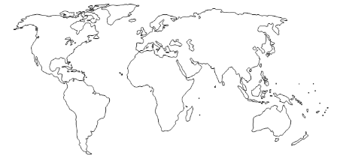

**2 - Checkout page app version:** We delete repeated content such as “First Name”, “Date of Birth” and “Email Address” to make the website easier to read and type. There wasn’t any need to read it twice since the text was already within the input box if the user hadn’t yet typed anything. The is especially designed for older people (Persona 2) as it would be harder to find where to input the text as it was too cluttered.

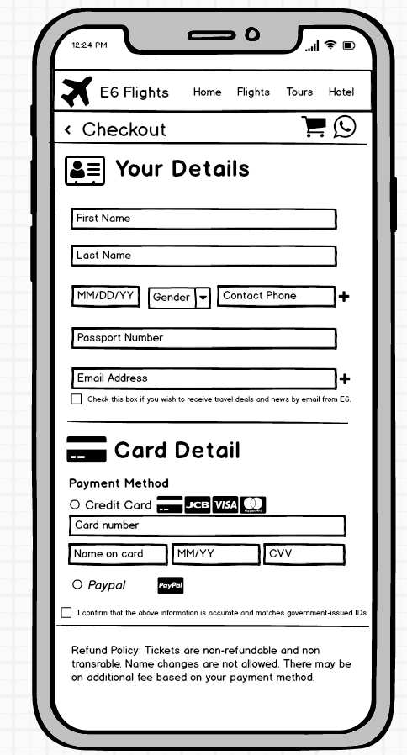

**3 - Log in / Sign up page** **web & app:** We changed the button for alternate option to a hyperlink that would not cause mis click.

The original page and the changed one is shown below.

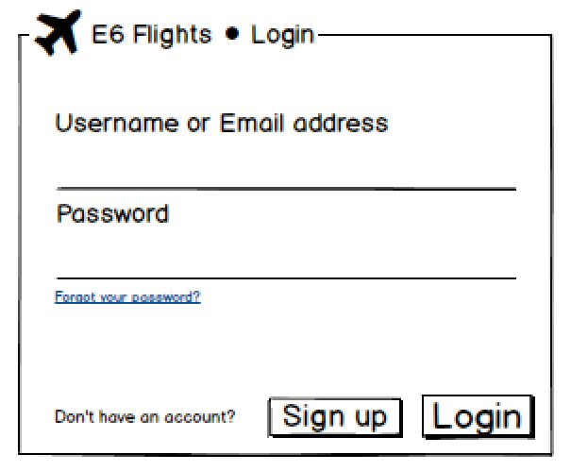 → 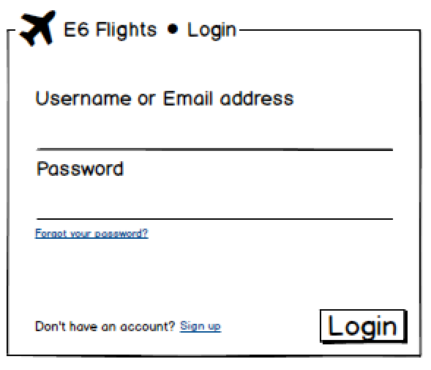

**4 - Flight listing page both version:** We removed some of the useless details in each item to make them look clearer and not as crowded as before, for instance, the time zone of different airport are now moved to detail page. The diagram shown is the changed page.

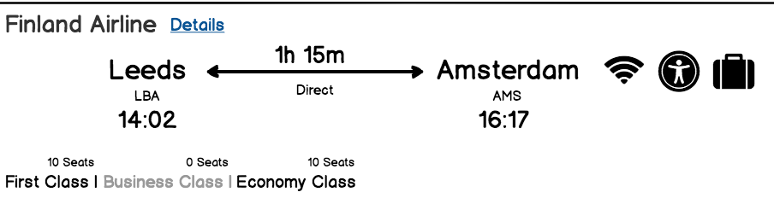--> 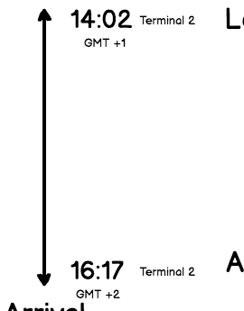

**5 - Travel Page:** The system now includes a feature where users can do a more detailed search for number of seats of the type of transmission. This allows a more refined view of the vehicles and a better choice for the users without having to spend a long time searching. Resultantly, this more benefits persona 1 as the system is quicker to use.



**6**- **Travel Page:** Added a like button in which the users favourites can be saved for another time or filter more searches similar. These favourites are saved to the account that’s logged into.

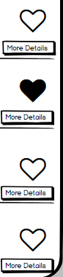 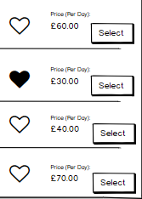

**7 - Travel Pages**: Users can now filter through cars with a drop down box, this allows price, year and other options to be ordered

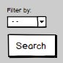

**8 - Hotels pages:** On the filtering section, there was no way to search for just hostels of hotels which would make the system harder to use for both students and families so this addition was included on to the filtering sections of both. See appendix H.

**9 - Messages Page:** The size of the minimise and back buttons on the mobile page was increased to decrease the likelihood of being missing the button and also make them more prominent for visually impaired users. See appendix F.

**10 - Messages Page:** To help users take advantage of the assistance of this feature, a pop up link to make this page display when clicked now appears after a few minutes on the website.

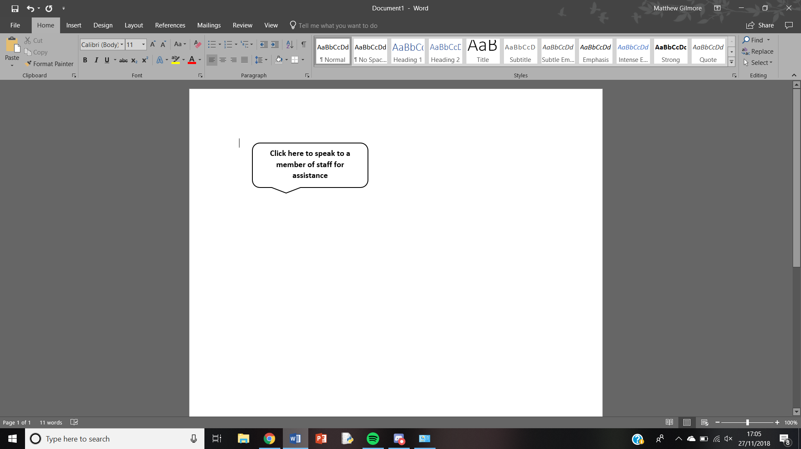

## **Appendices**

Appendix A

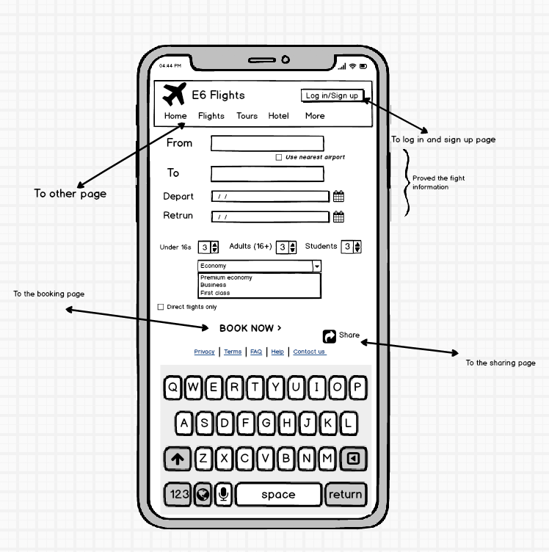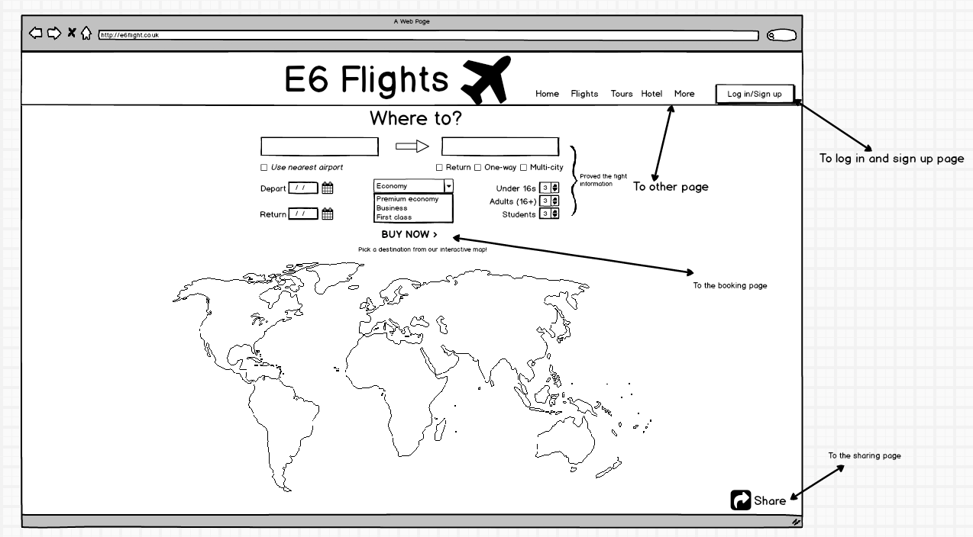

Appendix B

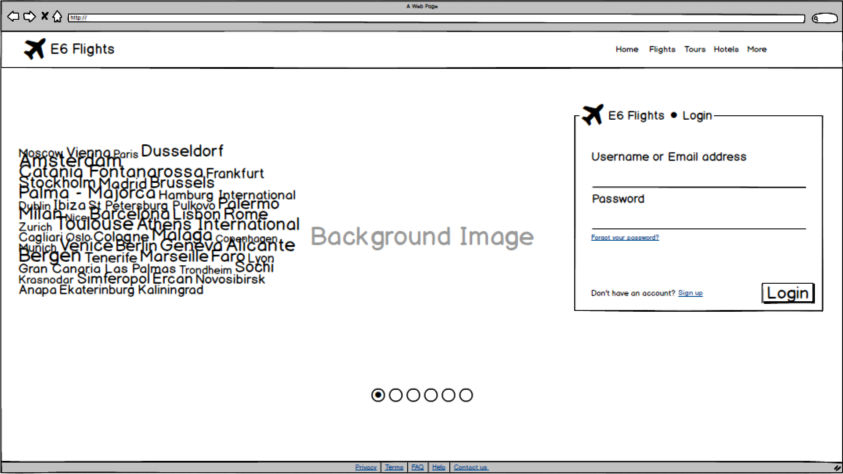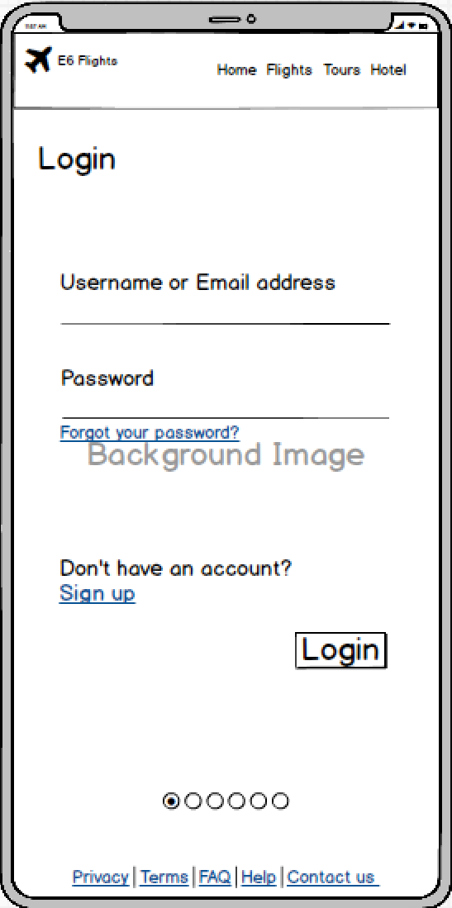

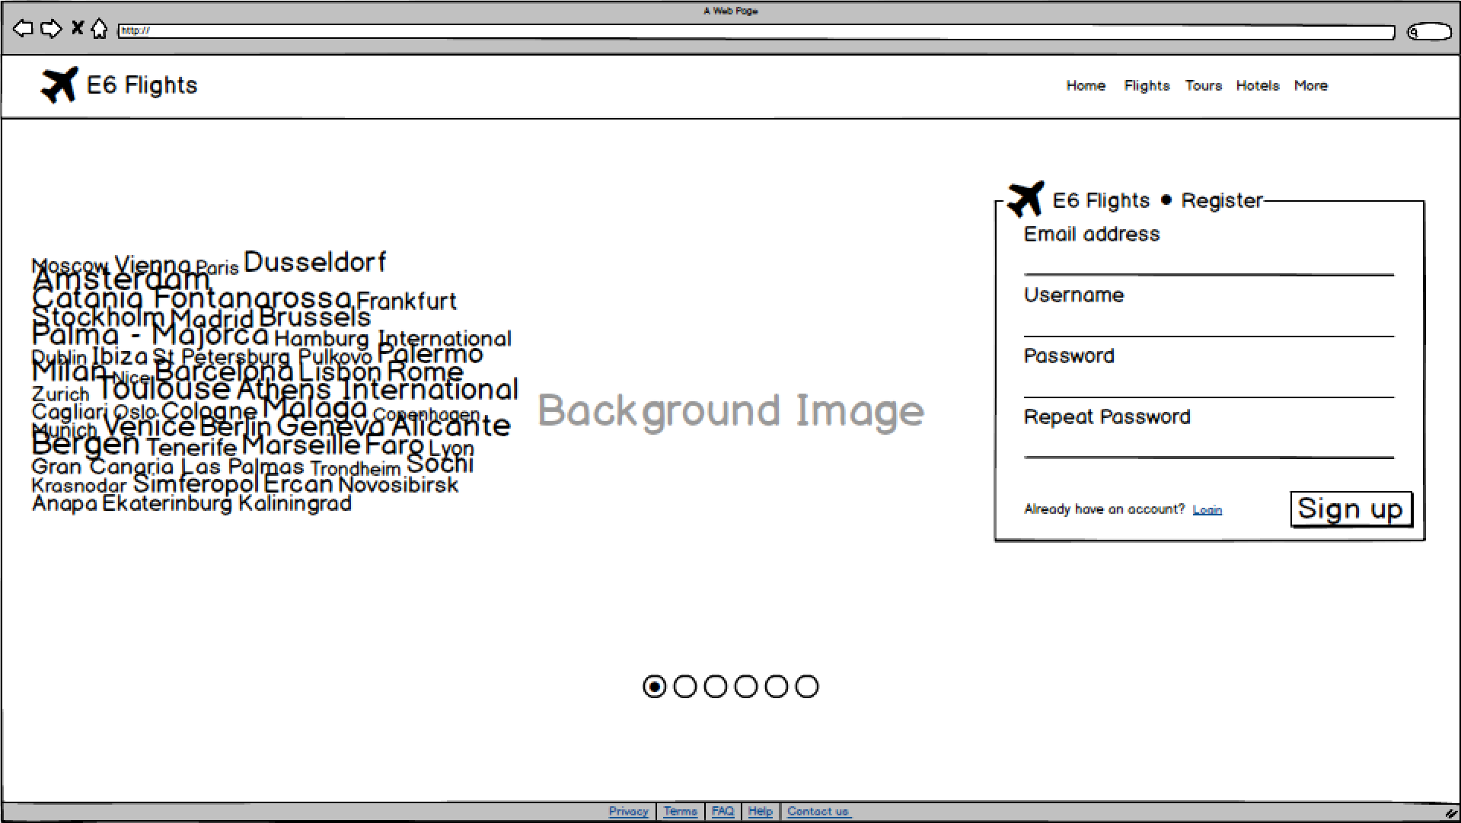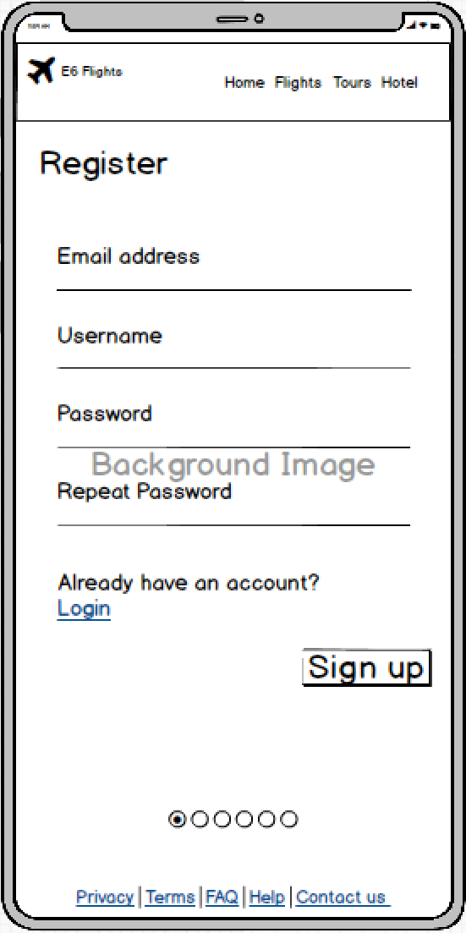

Appendix C

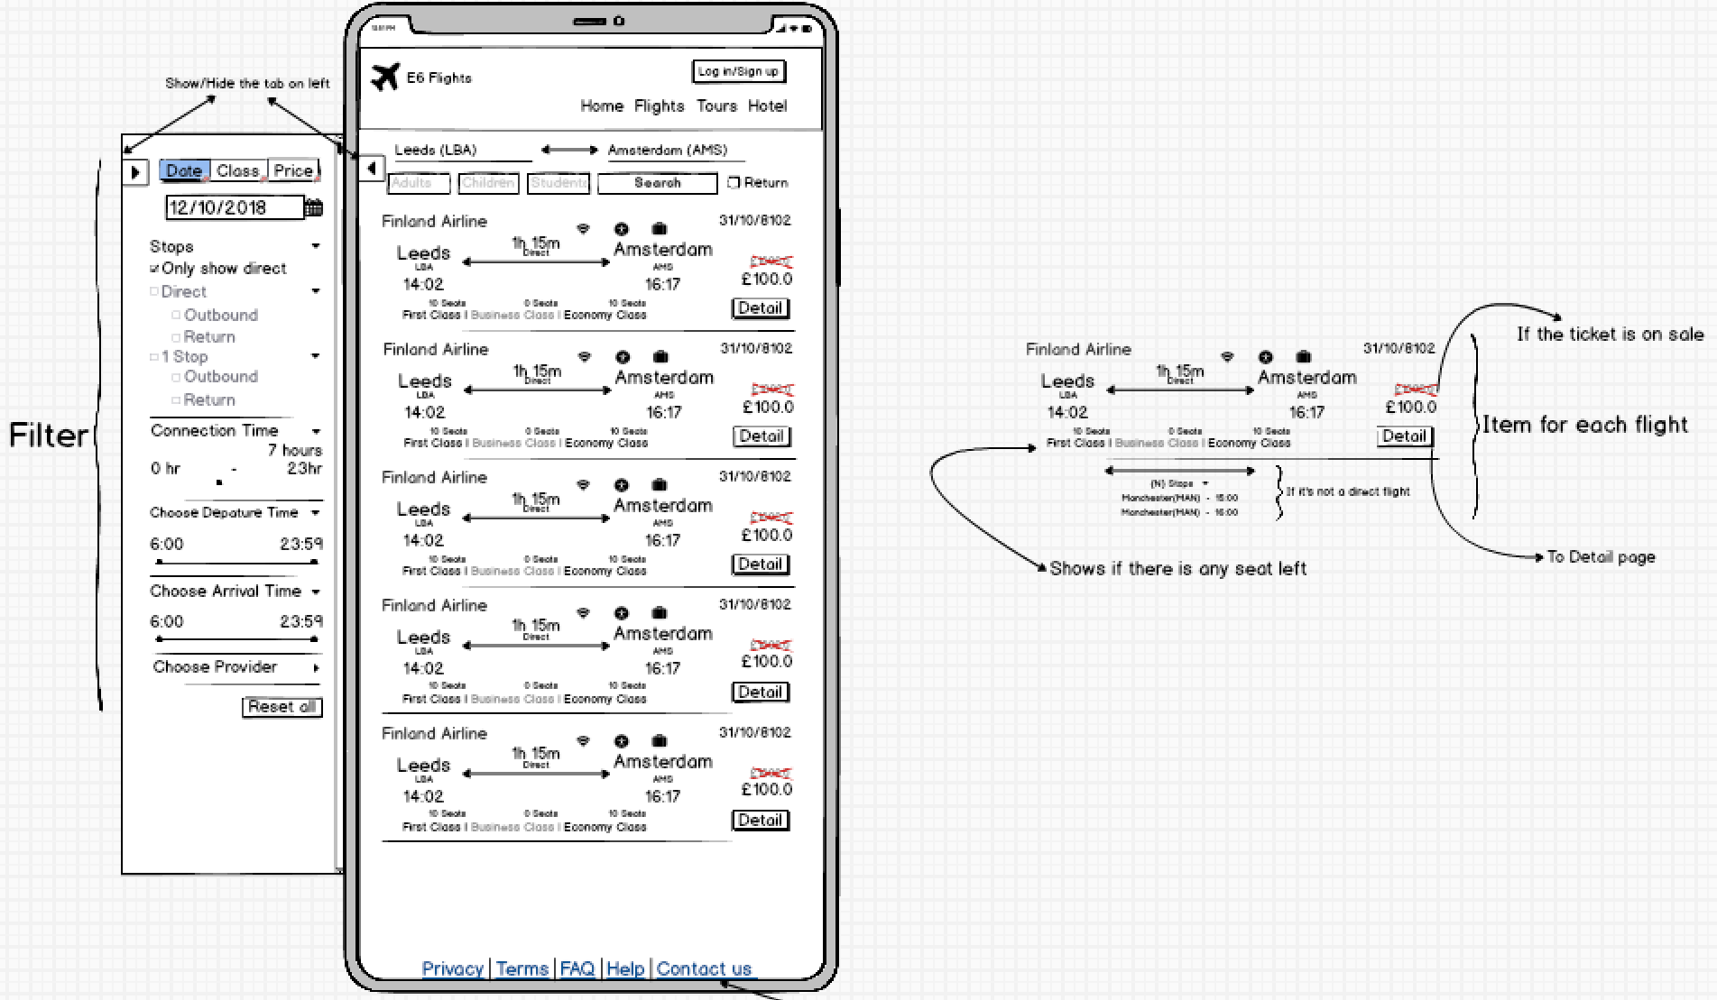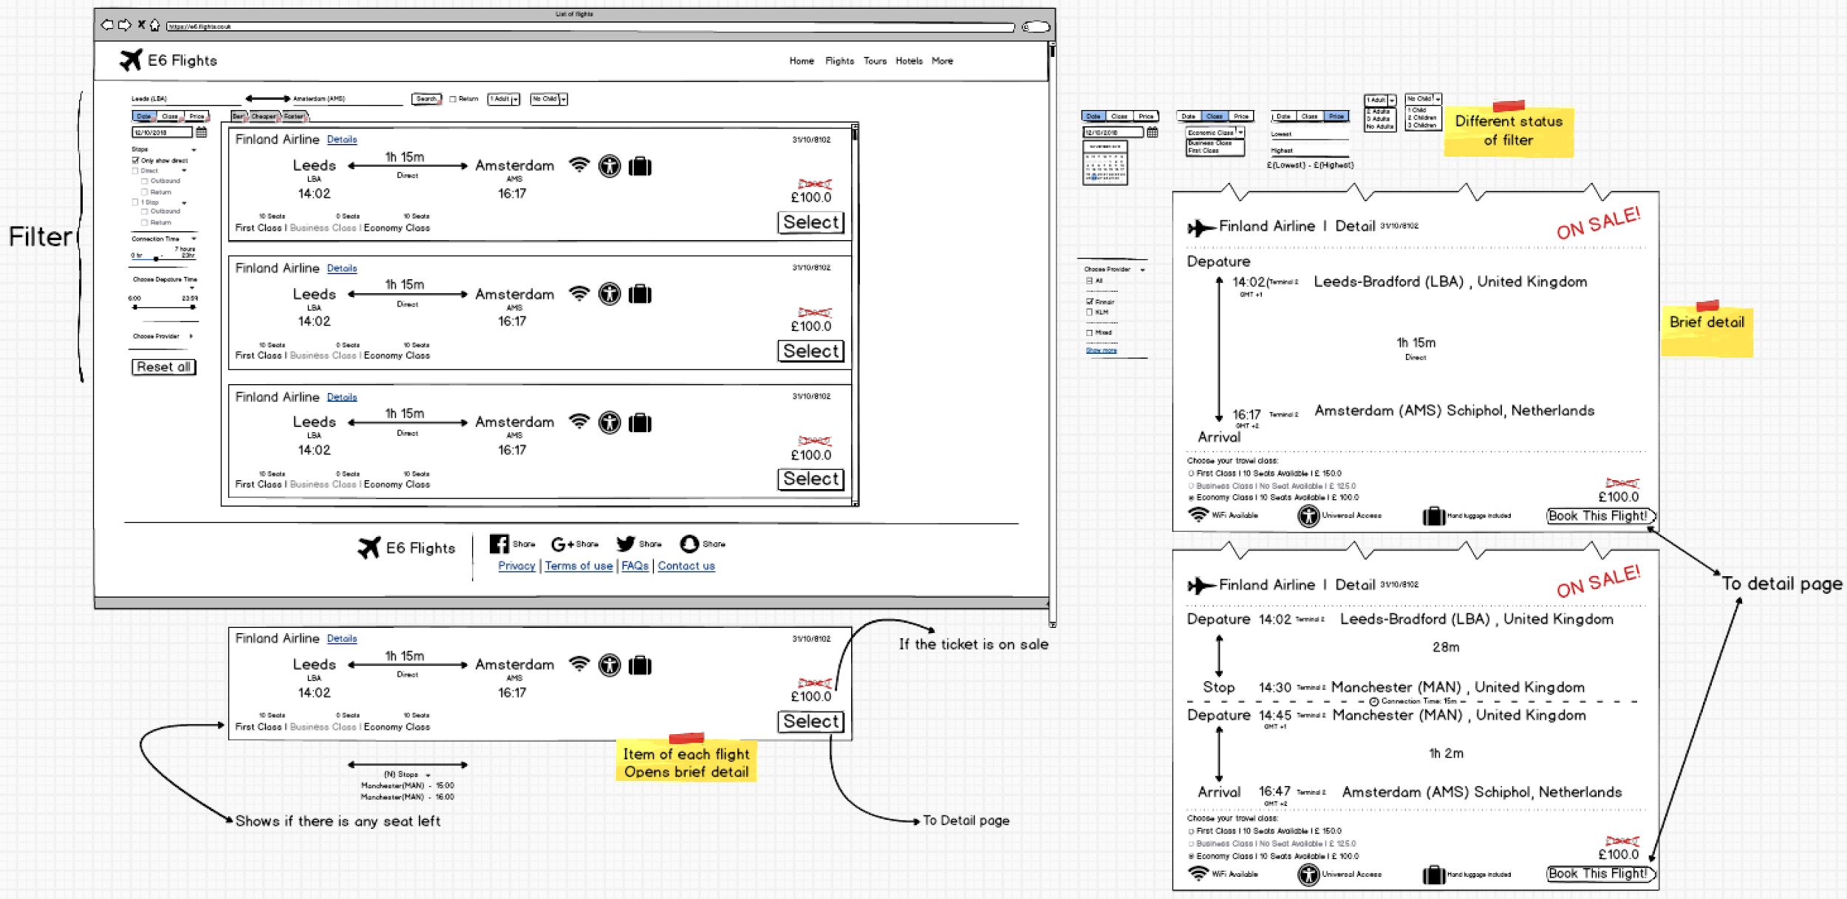

Appendix D

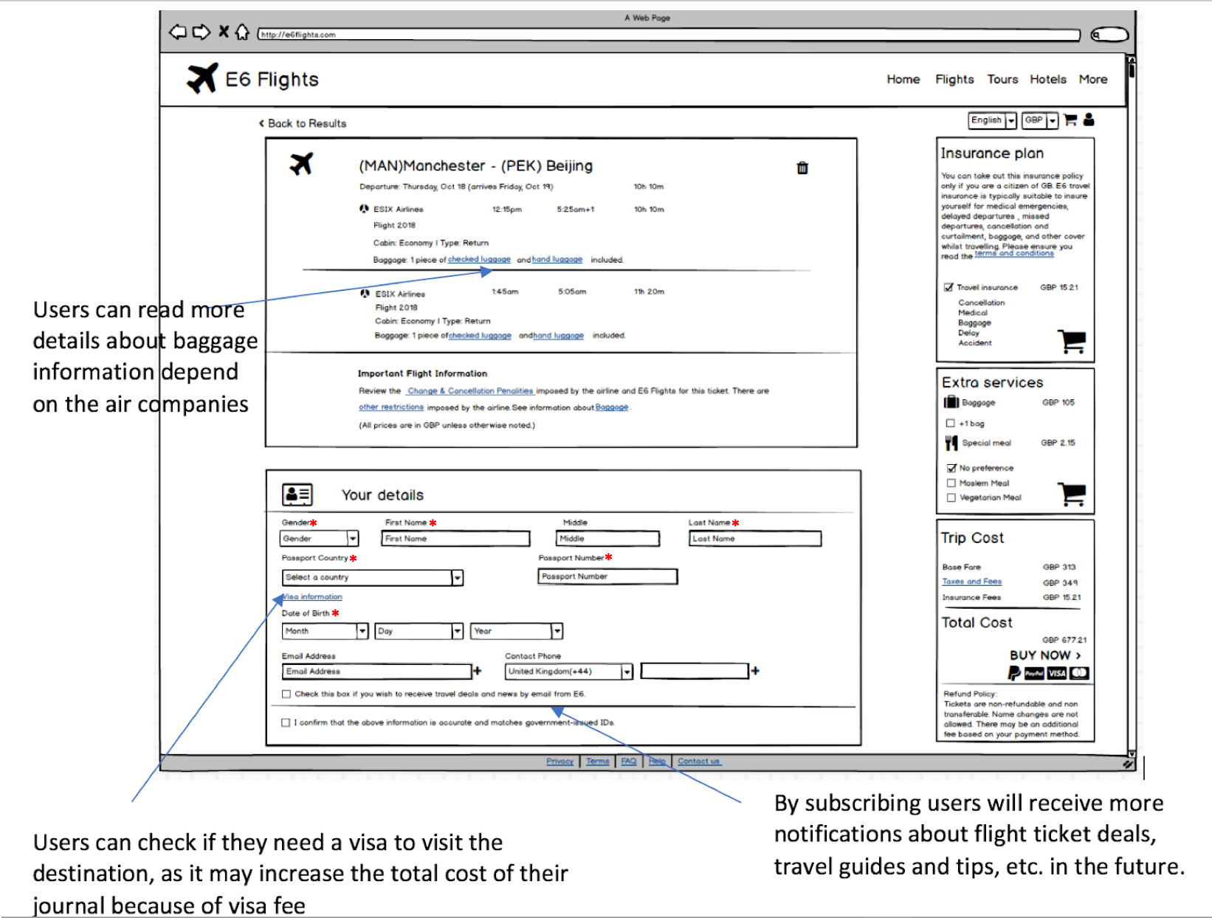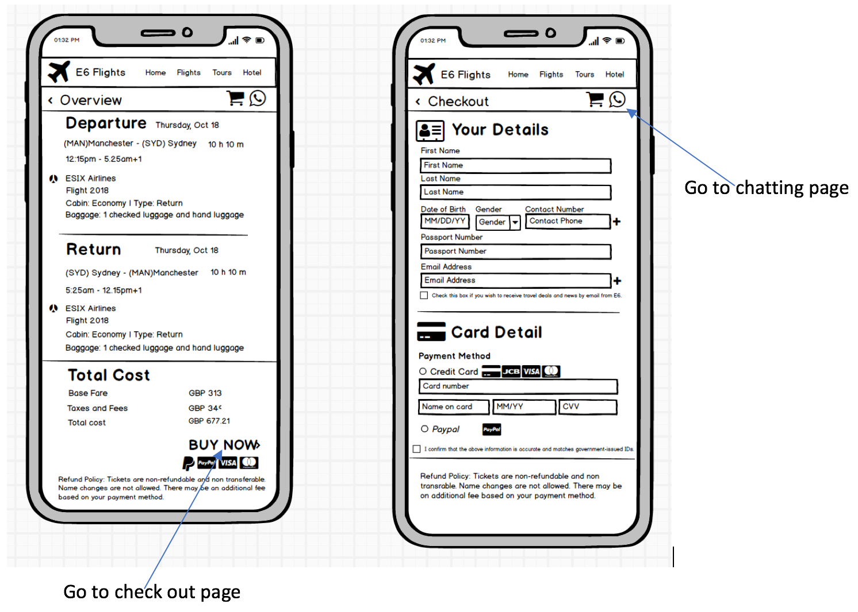

Appendix E

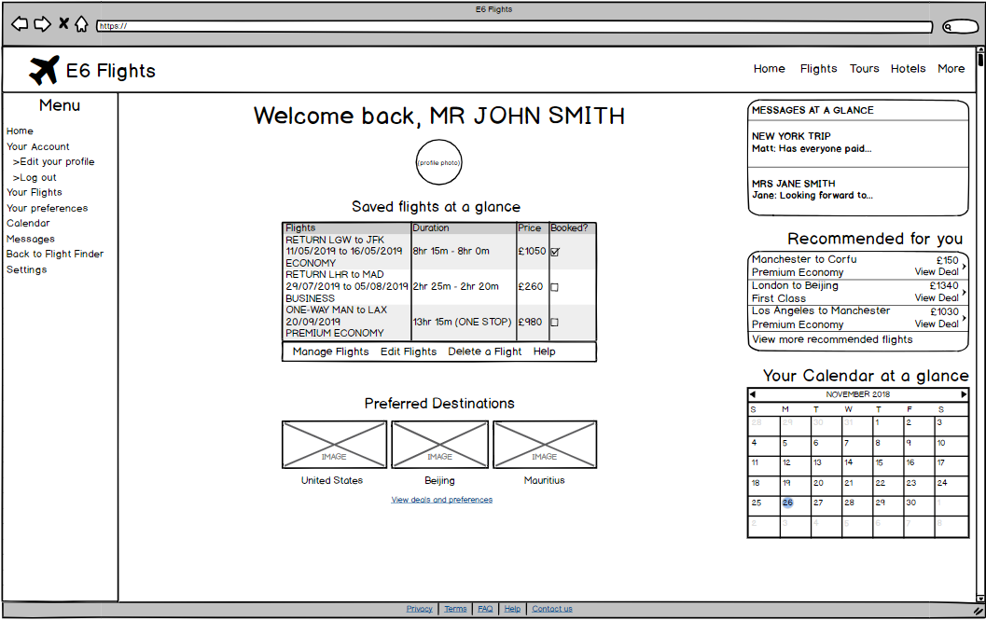

## 

Appendix F

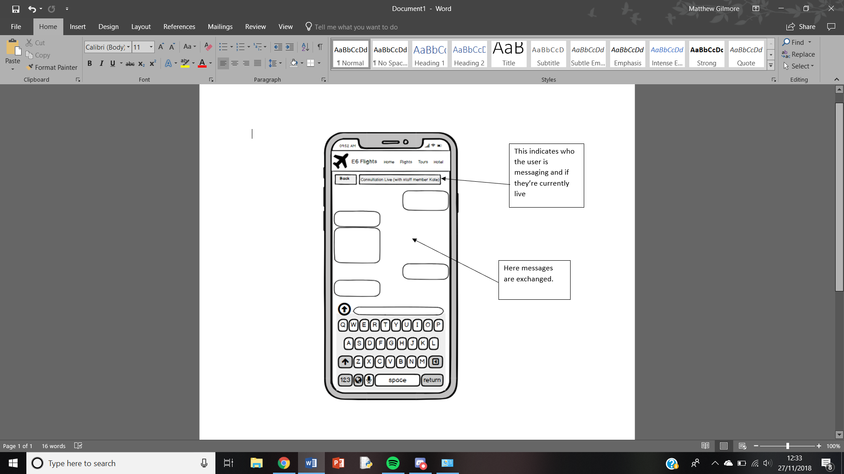

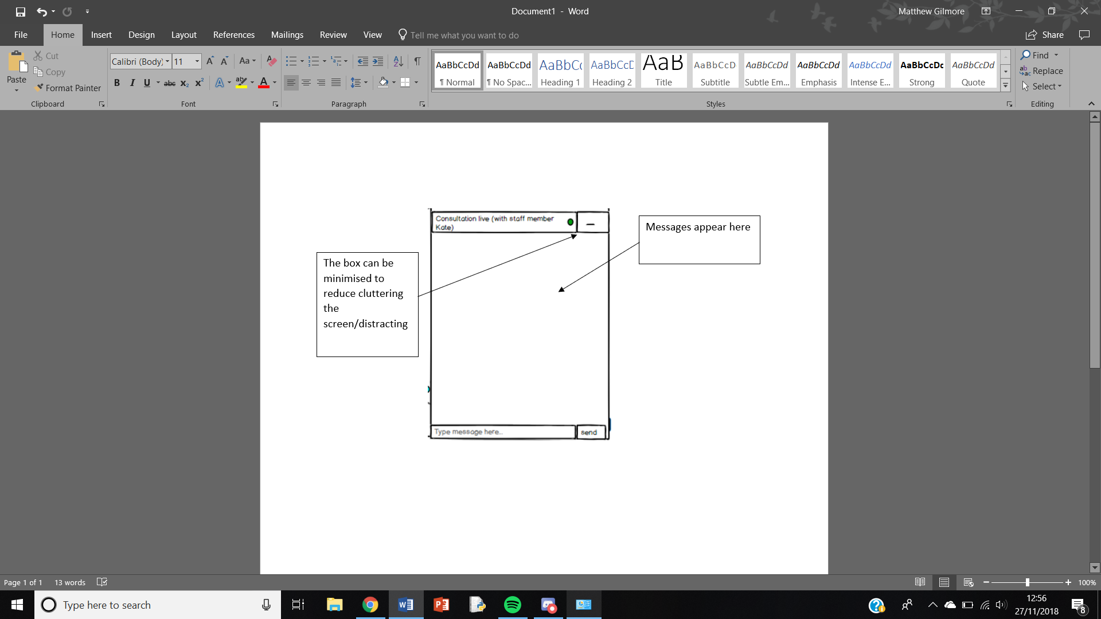

Appendix G

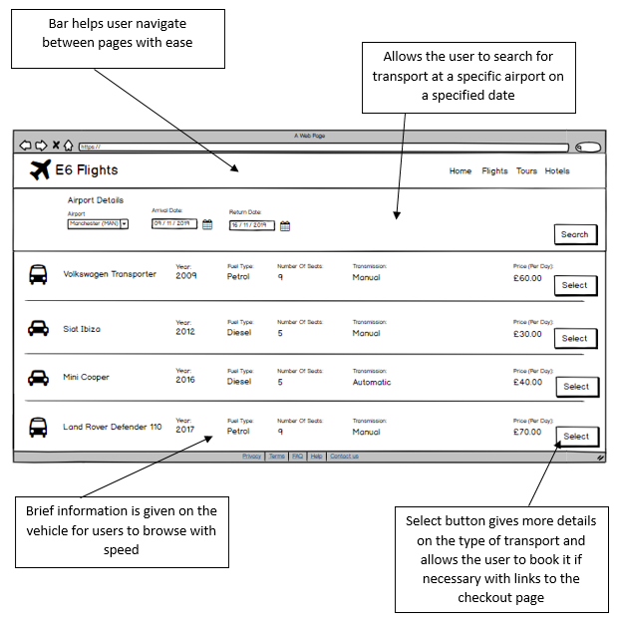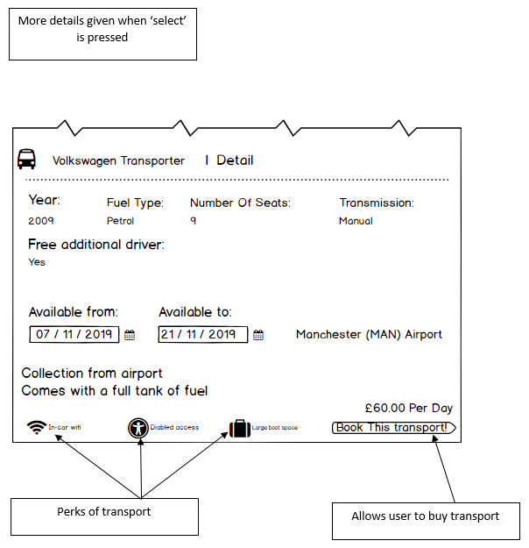

Appendix H

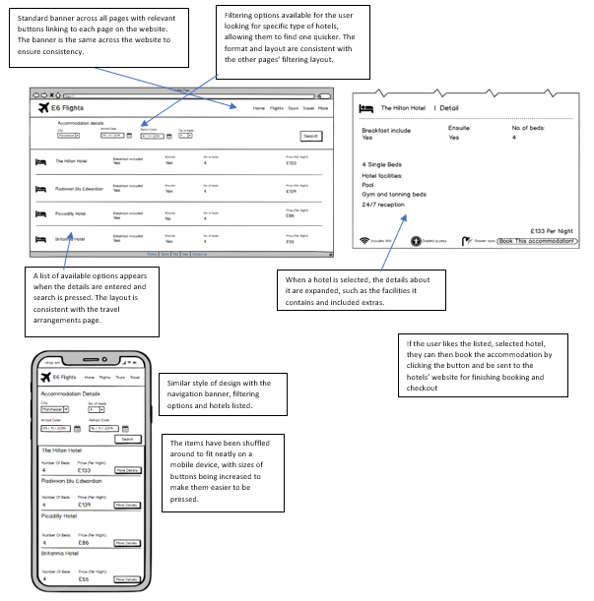

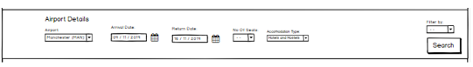

Appendix I

|  |  |  |  |  |  |
| --- | --- | --- | --- | --- | --- |
| **Heuristic Violated** | **Severity Rating** | **Page** | **Update Type** | **Update reason** | **How it can be improved** |
| 1 | 1 | Home Page | Unclear Aesthetics | The blue points on the map is meaningless. | Remove blue points and just have clickable places. |
| 2 | 2 | Check Out | Layout | The layout of App version website is not very clear, i.e., repeated content, too crowded. | Delete repeated context |
| 2, 4 | 1 | Log In /Sign up | Background image | The images may confuse the color-blind customers | Use a grey overlay to make them less catchy |
| 2 | 2 | Log In /Sign up | Fonts | Too small for senior users | Enlarge the fonts |
| 2 | 1 | Log in /Sign up | Sign up button | May cause mis-click | Change to hyperlink |
| 1 | 2 | Flight list | Item layout | Too crowded | Remove some detail of flight |
| 2 | 2 | Flight list | Fonts | Too small for senior users | Enlarge the fonts |
| 1 | 1 | Flight list(phone) | Filter | May cause mis-click | Increase padding |
| 17 | 3 | Travel | Advanced Search | Cannot look for cars that are only a certain type due to no refining search | Needs to add a search refining amount of seats, price and transmission type |
| 17 | 2 | Travel | Favourites | Cannot favourite cars to be looked at at a later time | Add favourite function |
| 17 | 1 | Travel | Filter by feature | Cannot filter cars, for example ‘Price: Low to High’ | Added filter box which allows the user to choose what the cars are filtered by. |
| 8 | 2 | Message | Pop Up | Page hard to navigate to/too imbedded | Small information pop up linking to the message page when the site is accessed |
| 2 | 1 | Message | Send message button | Send button too small and can be easily misclicked | Increase its size |
| 15 | 2 | Hotels | Filter by feature | No option to filter between hotels and hostels | Added the option onto filtering section. |

## **References**

[1] Bruce Tognazzini, 2003, https://asktog.com/atc/principles-of-interaction-design/ , accessed 12/11/2018